SCHOOL OF COMPUTER SCIENCE AND ARTIFICIAL INTELLIGENCE |  |  |  |  | DEPARTMENT OF COMPUTER SCIENCE ENGINEERING
Program Name: B. Tech |  |  |  | Assignment Type: Lab |  |  | Academic Year:2025-2026
Course Coordinator Name |  |  |  | Venkataramana Veeramsetty
Instructor(s) Name |  |  |  | Dr. V. Venkataramana (Co-ordinator)  Dr. T. Sampath Kumar  Dr. Pramoda Patro  Dr. Brij Kishor Tiwari  Dr.J.Ravichander  Dr. Mohammand Ali Shaik  Dr. Anirodh Kumar  Mr. S.Naresh Kumar  Dr. RAJESH VELPULA  Mr. Kundhan Kumar  Ms. Ch.Rajitha  Mr. M Prakash  Mr. B.Raju  Intern 1 (Dharma teja)  Intern 2 (Sai Prasad)  Intern 3 (Sowmya)  NS_2 ( Mounika)
Course Code |  |  | 24CS002PC215 | Course Title |  | AI Assisted Coding
Year/Sem |  |  | II/I | Regulation |  | R24
Date and Day  of Assignment |  |  | Week11 - Tuesday | Time(s)
Duration |  |  | 2 Hours | Applicable to  Batches
AssignmentNumber:22.1(Present assignment number)/24(Total number of assignments)
 | Q.No. | Question |  |  |  |  |  | Expected Time  to complete
 | 1 | Lab 22 – Advanced Ethical Considerations: Addressing Complex Scenarios and Limitations  Lab Objectives:  - Understand ethical concerns in AI-assisted coding.  - Explore complex real-world scenarios where AI decisions have consequences.  - Learn to identify limitations and biases in AI-generated solutions.  - Encourage critical thinking and human responsibility in AI collaboration.  Task 1 – AI and Inclusivity  • Ask AI to generate a chatbot for customer support.  • Test if it handles multiple languages or accessibility features (e.g., screen readers).  • Discuss:  How lack of inclusivity creates digital inequality.  Ethical ways to ensure accessibility in AI-generated systems  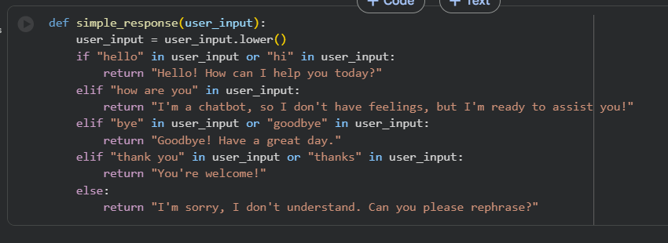  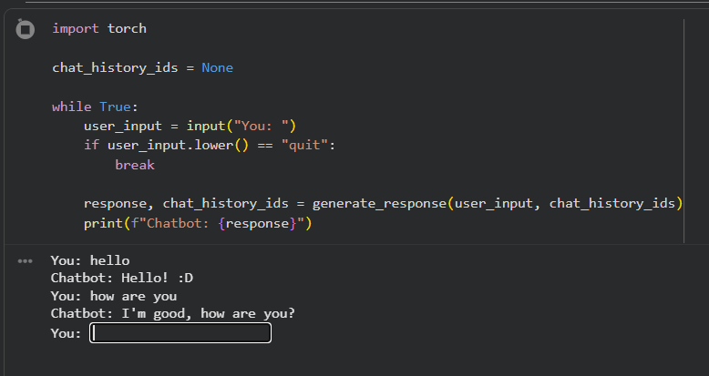  Task 2 – Intellectual Property and Plagiarism  - Ask AI to write a code snippet for image compression.  - Check if AI reuses code from open-source libraries without attribution.  Discuss:  - How copyright violations affect developers.  - Best practices for attribution when using AI-generated code.  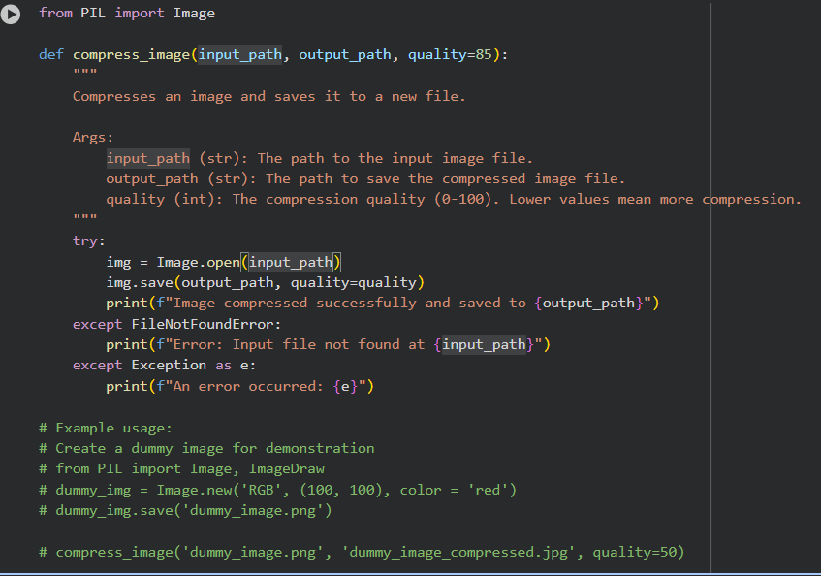  Task 3 – Dual-Use Code Risks  Use AI to generate a network scanning tool.  Discuss how the same tool can be used for ethical cybersecurity testing or illegal hacking.  Debate whether AI should refuse such requests, and where to draw the line.  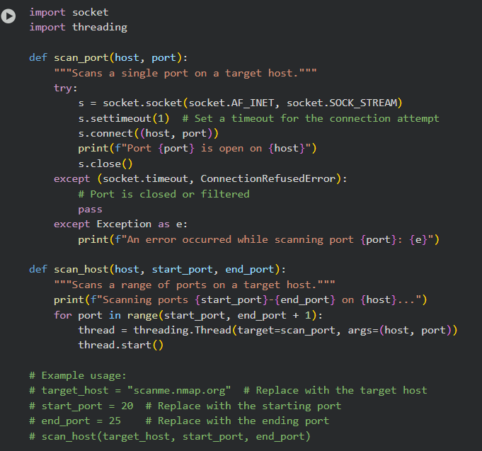  Task 4 – Human Oversight in Healthcare  - Scenario: AI writes code for detecting heart anomalies from ECG data.  - Discuss:  Should doctors rely fully on AI outputs?  - Generally, no, doctors should not rely fully on AI outputs for diagnosis, especially in critical areas like heart anomalies. AI should be viewed as a powerful tool to assist and augment a doctor's expertise, not replace it.  - AI can help by quickly analyzing large amounts of data, identifying patterns that might be missed, and providing a preliminary assessment or highlighting areas of concern. However, the final diagnosis and treatment plan should remain with the qualified medical professional who can consider the full clinical picture, patient history, and other relevant factors that AI might not capture.  What oversight is mandatory before deployment in real hospitals?  • Rigorous validation and testing in diverse clinical settings is absolutely essential. The AI model needs to demonstrate high accuracy, sensitivity, and specificity on real-world data that represents the patient population it will serve.  • Regulatory approval from relevant health authorities (like the FDA in the US) is mandatory. This involves demonstrating the AI's safety and effectiveness.  • Transparency and explainability of the AI's decision-making process are crucial. Doctors need to understand why the AI is suggesting a certain anomaly to build trust and identify potential biases or errors.  • Data privacy and security must be paramount. Patient ECG data is sensitive, and robust measures are needed to protect it.  • Continuous monitoring and updates are necessary after deployment. AI models can degrade over time with changes in data distribution or patient populations.  • Training and education for medical staff on how to properly use and interpret the AI's outputs are vital  How should responsibility be shared?  This is a complex legal and ethical question that is still evolving.  Shared responsibility between the AI developer/provider, the healthcare institution, and the medical professional using the tool is likely the most appropriate approach.  The AI developer is responsible for building a robust, validated, and safe system.  The healthcare institution is responsible for proper implementation, integration into workflows, and ensuring staff are trained.  The medical professional remains responsible for the final diagnosis and treatment decision, using the AI as a tool within their practice. They are accountable for their medical judgment.  Clear guidelines and legal frameworks are needed to define the scope of responsibility for each party in case of errors or adverse outcomes  Task 5 – AI in Decision-Making  - Ask AI to generate a loan approval system.  - Analyze if the decision process is explainable to users.  - Discuss:  - What risks arise if AI decisions are a “black box”?  - How explainability ensures fairness in financial decisions  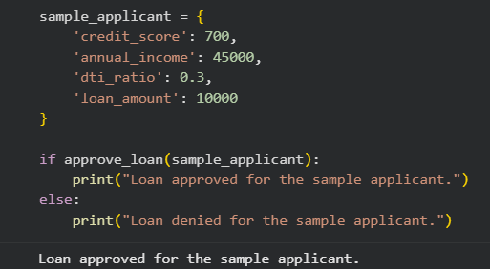  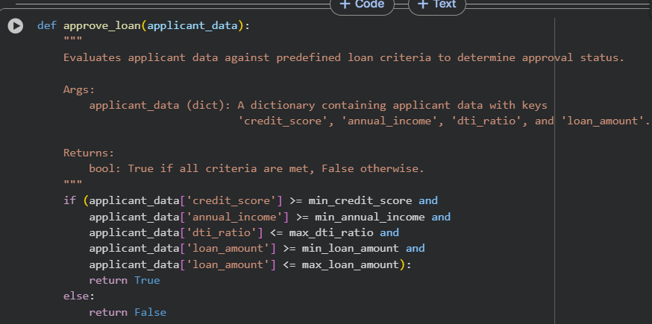  Task 6 – Environmental and Societal Impact  Students explore how large-scale AI coding assistance affects energy consumption (cloud servers, GPUs).  Discuss:  Is there an ethical responsibility to consider sustainability?  How should developers balance performance vs environmental cost?  Ethical responsibility for sustainability? Yes, there's a growing ethical responsibility. As AI becomes more prevalent and energy-intensive, developers and users should consider its environmental footprint and strive for more sustainable practices.  Balancing performance vs. environmental cost? This is a key challenge. Developers can balance performance and environmental cost by:  Choosing energy-efficient hardware.  Optimizing models for efficiency.  Utilizing renewable energy sources for data centers.  Considering the trade-offs between model size/complexity and the required computational resources.  It's about finding ways to achieve powerful AI capabilities while minimizing the energy consumed and the resulting environmental impact…  Expected Outcomes:  - Students evaluate inclusivity, transparency, and accountability in AI coding.  - Students identify risks of dual-use and misuse of AI-generated code.  - Students understand broader societal and environmental implications of AI-assisted coding.  ✅ Deliverables (For All Tasks)  - AI-generated prompts for code and test case generation.  - At least 3 assert test cases for each task.  - AI-generated initial code and execution screenshots.  - Analysis of whether code passes all tests.  - Improved final version with inline comments and explanation.  - Compiled report (Word/PDF) with prompts, test cases, assertions, code, and output. |  |  |  |  |  | Week11 - Monday

